 | MIDTERM REPORT  Undergraduate Research Opportunities Program 1 (UROP1010)
Student name: | Nguyen Thi Phuong Thao | Date: | 14/ 04/2026
Student ID: | V202401781 | Year: | 2
College: | Engineering and Computer Science | Program: | Data Science
Faculty supervisor name: | Professor Saeid Sanei
Research Project Title:
Murmur Separation and Classification from Heart Sound Using Constrained Singular Spectrum Analysis and Wavelet Transform
- Project Overview (20 points)
Please provide a brief overview of the research project, outlining its goals, objectives, and significance in the respective field of study.
This research project focuses on reproducing and analyzing a murmur separation and classification pipeline proposed in the paper “Murmur Separation and Classification from Heart Sound Using Constrained Singular Spectrum Analysis and Wavelet Transform.” The study aims to investigate whether separating heart murmurs from normal heart sounds before classification can improve the performance of automated heart sound analysis systems.

Heart murmurs are abnormal acoustic signals produced by turbulent blood flow in the heart and are important indicators of cardiovascular diseases. However, in real auscultation recordings, murmurs often overlap with normal heart sounds, making them difficult to detect accurately. As described in the paper, distinguishing murmurs from normal cardiac signals is a challenging problem because both components coexist within the same audio signal and may share ove rlapping frequency characteristics.

To address this challenge, the paper proposes a two-stage murmur separation framework followed by machine learning–based classification. In the first stage, Constrained Singular Spectrum Analysis (CSSA) is used to decompose the heart sound signal into multiple components. The normal heart sound is then reconstructed using statistical constraints such as Zero Crossing Rate (ZCR) or kurtosis optimization, allowing the murmur to remain as a residual signal. In the second stage, a Wavelet Transform (WT) is applied to further refine the separation and remove residual murmur components that remain mixed with the heart sound. This two-stage process aims to improve the precision of murmur extraction before performing classification.

After murmur separation, the extracted signals are classified using several machine learning approaches, including Support Vector Machines (SVM), Random Forest (RF), Convolutional Neural Networks (CNN), and transfer learning with Wav2Vec 2.0. These models utilize different feature representations such as MFCC features, Mel spectrograms, or raw audio waveforms to distinguish between different murmur types. Experimental results reported in the paper suggest that performing murmur separation prior to classification improves model performance, achieving classification accuracy above 99% for certain models.

This work represents Phase 1 of the Murmur Separation and Classification Project. The objective of this phase is to reproduce the signal processing and classification pipeline described in the paper. The focus is on rebuilding the methodology and verifying that the pipeline can be implemented and executed successfully using available datasets.

It is important to note that the original paper does not provide several critical implementation details, including dataset composition, parameter settings for SSA decomposition, wavelet configuration, and model training parameters. Therefore, the goal of Phase 1 is not to exactly replicate the numerical results reported in the paper, but rather to reconstruct the pipeline based on the methodological description and ensure that the proposed approach can be implemented.

By reproducing the separation and classification pipeline, Phase 1 establishes the technical foundation for the remaining stages of the project. This step is essential for validating the feasibility of the proposed approach and preparing for further experimentation and improvements in later phases of the research.

Project Github link: https://github.com/The-platypus20/murmur-separation-reproducibility.git

- Progress Update (50 points)
Please write an overview of your tasks and progress in the research project, detailing your accomplishments, challenges faced, and the steps taken to overcome these challenges. Include any significant findings or developments in the project.

This section summarizes the progress made so far in the Murmur Separation and Classification project. The current stage of the project focuses on implementing and validating the first stage of the murmur separation pipeline, which is Constrained Singular Spectrum Analysis (CSSA). The objective of this stage is to separate normal heart sounds from murmurs using statistical constraints before applying further refinement methods.

Task 1: Literature Review and Method Understanding:
The fundamental task is carefully reviewing the research paper and understanding the proposed signal processing pipeline for murmur separation and classification. The study proposes a two-stage separation framework where Constrained Singular Spectrum Analysis (CSSA) is used for initial separation, followed by Wavelet Transform (WT) for refinement. The CSSA stage decomposes the heart sound signal into multiple components and reconstructs the normal heart sound using statistical constraints such as Zero Crossing Rate (ZCR) or kurtosis optimization. The murmur component is then obtained as the residual signal.

During this phase, the methodology described in the paper was analyzed in detail, including the mathematical formulation of Singular Spectrum Analysis (SSA), the trajectory matrix construction, eigen-decomposition, and component reconstruction. Understanding these steps was essential for implementing the algorithm correctly. One challenge encountered during this stage was that the paper does not fully specify several important implementation details, such as parameter values for SSA window length, threshold settings for ZCR, and the configuration of the genetic algorithm used for kurtosis optimization. To address this issue, reasonable assumptions and parameter selections were made based on common practices in signal processing literature.

Task 2: Implementation of CSSA-Based Murmur Separation:
Next task is to implement the CSSA-based murmur separation algorithm. The process begins by applying Singular Spectrum Analysis (SSA) to the heart sound waveform. SSA converts the one-dimensional signal into a trajectory matrix using a sliding window, after which eigenvalue decomposition is applied to extract signal components. These components represent different structural patterns within the signal, including normal heart sounds, noise, and murmurs.

Two different constraint strategies were implemented for reconstructing the normal heart sound:

1. CSSA with Zero Crossing Rate (ZCR)
In this approach, the zero-crossing rate of each SSA component is calculated. Components with lower ZCR values are assumed to correspond to normal heart sounds, while components with higher ZCR values are more likely associated with murmur signals. Components satisfying the threshold condition are selected and used to reconstruct the estimated normal heart sound. The murmur signal is then obtained by subtracting the reconstructed heart sound from the original signal.

2. CSSA with Kurtosis Optimization
The second method reconstructs the heart sound signal by selecting SSA components that maximize kurtosis. Kurtosis measures the peakedness of the signal distribution and helps identify characteristic features of heart sounds. In the original paper, the optimization is performed using a genetic algorithm to determine the optimal component selection vector. For the current implementation, a simplified optimization strategy was used to approximate this process.

Both approaches were implemented and tested using heart sound recordings from the dataset. The resulting signals include the reconstructed heart sound and the residual murmur signal.

Task 3: Evaluation and Comparison of CSSA Separation Methods:
After implementing both CSSA separation methods, the next task involved evaluating their effectiveness and comparing their results. For each method, the reconstructed heart sound signal and the murmur residual signal were visualized and analyzed.

The following figures illustrate the separation results obtained using both constraints:

CSSA separation using Zero Crossing Rate (ZCR):
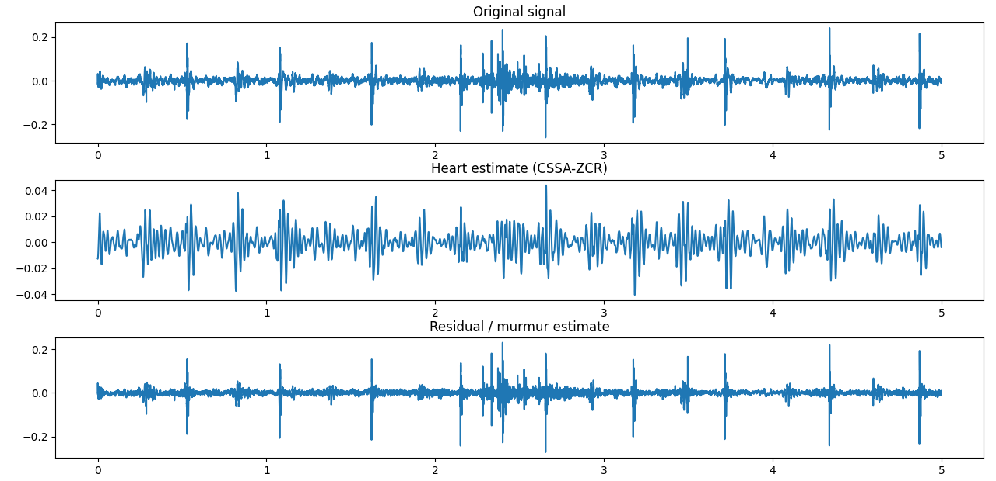

CSSA separation using Kurtosis optimization:
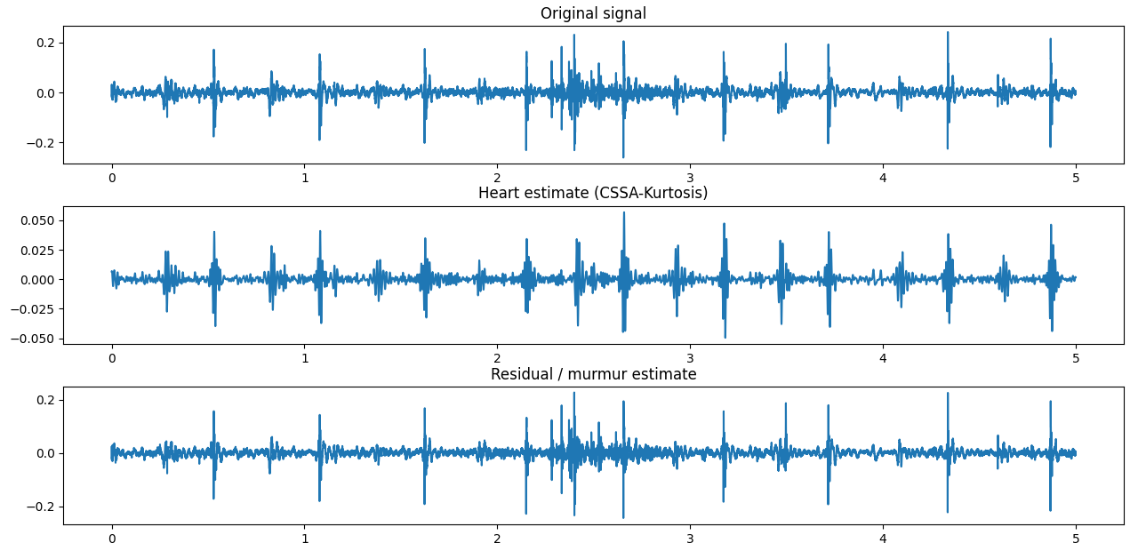

The plots show three signals: the original heart sound, the reconstructed heart sound estimate, and the residual murmur signal. The reconstructed heart sound primarily contains periodic cardiac activity, while the residual signal contains higher-frequency murmur components and noise.

The comparison indicates that both methods are capable of separating the main heart sound structure from the murmur component. However, the separation quality varies depending on the statistical characteristics of the signal. According to the methodology proposed in the paper, the final method should be selected based on the correlation between the reconstructed heart sound and the residual murmur, where the method producing lower correlation indicates better separation.

At the current stage of the project, the CSSA separation pipeline has been successfully implemented and validated through visualization and preliminary signal analysis. The next step of the project is to implement Stage 2 of the pipeline, which applies Wavelet Transform (WT) to further refine the separation and remove residual murmur components that remain after CSSA processing.

CSSA Method Comparison:
Two CSSA reconstruction strategies were evaluated: ZCR-based selection and kurtosis-based selection. The separation quality was assessed using the correlation between the reconstructed heart sound and the murmur residual. Lower correlation indicates better signal separation. Experimental results showed that the ZCR-based method produced a lower correlation value (0.285) compared to the kurtosis-based method (0.449). Therefore, the ZCR constraint was selected as the final CSSA reconstruction method for the subsequent wavelet refinement stage.

- Self-Evaluation (30 points)
Please assess your performance during the project based on the following evaluation criteria on a scale of 1 to 5 and make specific comments in each category.
(1-Unsatisfactory performance; 2-Below expectation; 3-Average performance; 4-Good performance; 5-Excellent performance)

Criteria | 1 | 2 | 3 | 4 | 5 | Comment
1 - I have maintained professionalism during the program (professional presence, punctuality, etc.) |  |  |  | x
2 - I have been able to complete given tasks with timeliness, accuracy, quality, and efficiency. |  |  |  |  | x
3 - I have demonstrated analytical thinking, critical thinking, and problem-solving skills while completing given tasks. |  |  |  |  | x
4 - I have proposed new ideas, creative initiatives and/or applied innovative methods/ways to complete given tasks. |  |  |  | x
5 - have demonstrated effective communication and collaboration with peers and supervisors (listen sincerely, be willing to help, be trusted, etc.) |  |  |  |  | x

What are your main strengths?
My main strength in this project is my prior experience with signal processing and data processing. This background helped me understand the concepts behind the murmur separation pipeline and implement the algorithms more efficiently. I am also able to work independently, analyze technical materials, and complete assigned tasks in a systematic and responsible manner.

What are your main areas of improvement?
One area I want to improve is gaining a deeper understanding of advanced signal processing techniques and optimization methods used in the research paper. Additionally, improve my ability to explore alternative approaches and experiment with different parameter settings to further enhance the performance of the implemented methods.

